SIMPLE ALWAYS WINS CONCEPTS LLC / SAW CONCEPTS LLC

ECO ECONOMIC HEARTBEAT / PROGRAMMABLE ECONOMY NAMESPACE

USPTO 13/573,002 HEART BEACON CYCLE TIME – SPACE METER

The Heart Beacon Cycle invention is an adaptive procedural template / checklist of good ideas, algorithms… to organize people in groups synchronized in time-space for a common purpose.

The Heart Beacon Cycle Time - Space meter is a swords to plowshares DAO Distributed Autonomous Organization project using NATO’s Situational Awareness system of systems engineering framework, processes, procedures and internet building blocks to establish an Ecologically sustainable Economic Heartbeat, neural network emulation for the EIN Earth Intelligence Network and heartbeat sync pulse for a Universal Time Zone UTZ supporting a one world currency. It’s syntax lexicon library of OPSCODE brevity codes used in programmable money, the programmable economy is descriptive of all things internet, internet of money down to the quantum computing, quantum blockchain level. a.k.a Project BEACON [/](https://bit.ly/2s6Fnav%20/) Medium Article [LINK](https://bit.ly/2s6Fnav) https://bit.ly/2s6Fnav

**We can synchronize ourselves and our cities in time - space for a common purpose: ecologically sound econometrics i.e., through use of a Signals and Telemetry annex for Buckminster Fuller’s Operations Manual for Spaceship Earth.  The HBC involves a heartbeat flash message universal event, alert message bus.  It is based on NATO's best practice, 300 + structured data exchange templates, micro-macro (economic) situational awareness sync delta data exchange schedule. The Heart Beacon cycle includes a universal metrics measurements physical meme (see Supreme Court Alice Corp Vs CLS Bank) for use among myriad Bitcoin Blockchain internet of money Blocktime arbitrage memes to support standardization of a one world economic system of systems MEDIUM ARTICLE** [LINK](https://medium.com/@heart.beacon.cycle/eco-sustainable-economic-heartbeat-43e4e30246da)



Eco - Economic Heartbeat / Programmable Economy Namespace System of Systems Framework

Economic RESET is a mathematical certainty. Question: Do we RESET the global system of systems as is business as usual or will we re-engineer using NATO / DARPA / DOD's system of systems engineering framework standing on the shoulders of giants to convert swords to plowshares? Medium Article [LINK](https://medium.com/@heart.beacon.cycle/eco-sustainable-economic-heartbeat-43e4e30246da)

HEART BEACON CYCLE ADAPTIVE PROCEDURAL TEMPLATE MAIN USE CASES:

1. Eco sustainable Economic Heartbeat / Programmable Economy Namespace

2. Distributed Autonomous Organization DAO support. The term DAO was coined by military think tank RAND Corporation circa 2001. Military’s always operate as organizations. NATO operations are usually distributed across many time zones and involve language translations.

3. Common signaling, telemetry, symbol, and data element sets help DAO’s stay synchronized. Joining autonomous trade federations using agile, adhoc [NetOps](https://en.wikipedia.org/wiki/NetOps) is an option to formal merger.

4. A key goal is to support federations: from Latin: foedus, gen.: foederis, covenant characterized by a union of partially self-governing states or regions under a central (federal) government.

5. Spatial econometrics. Geo-spatial, temporal metrics and meters will be universally consistent and synchronized across time zones. Micro to macro-cycle updates maintain system of systems

6. Universal Time Zone UTZ proposal using via improvement to the University of Bologna / Hungary’s firefly inspired heartbeat synchronization algorithm by matching the firefly synchronization pulse to the closest OPTEMPO Heart Beacon Cycle.

7. The "Grail" A sync'd shared situational awareness view among a system of systems showing statistical mean value indexes can be achieved by reuse of improved net centric warfare methods joined with establishing a universal event bus using firefly-inspired heartbeat synchronization

8. Supreme Court Alice Corp Vs CLS Bank compliant universal memes describe sync delta cyclic changes: describes linear sequential, geo-spatial temporal intensity radius hop count econometric metrics and meters where closer is shorter and closer is faster – eco sustainable

9. Algorithmic regulation: firefly inspired heartbeat synchronization algorithm in stock and currency exchanges is a segue to algorithmic regulation. Improving temporal trade parity between Bitcoin Blockchain & conventional stock exchanges by using the firefly-heartbeat algorithm to take trade speed samples among trade populations across time zones to establish consensus among disparate trade protocols, optimal trade speed / frequency as a statistical mean

10. Supporting economist Milton Friedman’s K% rule where a “FEDCOIN / WORLDCOIN currency could be derived from sampling lead economic indicators across a global, universal event bus applying the firefly-heartbeat algorithm tracking changes, updating statistical means

11. Big Data as the “Next Oil”: Establishing a consistent <tag> context library / lexicon and time stamping data by organization <Org_ID> and by data class type and by resource type to form a universal syntax, code, date element, tag Rosetta Stone and reference for coders, programmers

12. Universal meme metaphor for coders, programmers given all things internet are formed using time cycles / syntax as instructions for example, universal Bitcoin blockchain meme mediation

PATENT APPLICATION SUMMARY:

The Heart Beacon Cycle invention is an adaptive procedural template / checklist of good ideas and tools used to organize people in groups synchronized in time-space for a common purpose

1. US Supreme Court Alice Corp V CLS Bank: "claims ineligible for patent protection under 35 U. S. C. §101 "directed to an abstract idea" http://1.usa.gov/1V91pQe [LINK](http://1.usa.gov/1V91pQe) 13/573,002 achieves Supreme Court Alice Corp V CLS Bank compliance via a Little League Baseball Tournament physical meme embodiment. The opposite of abstract is physical. Physical, tangible memes are applied. Transco V Performance Contracting web screen captures establishes forming of a patent worthy idea. Protecting an idea involves award of a patent

2. All internet artifacts are formed using time epochs, cycles, intervals, periods to process or not process syntax as instructions. 10/605,144, 10/708,000 establish this idea / fact. The first and more importantly, the most useful metaphor / meme or “best” physical meme to form internet, internet of money, Internet of Things IeT etc. artifacts as theme variations is at stake.

3. A “Rosetta Stone” syntax lexicon code tag reference library is essential to help recode our world and enable Governance 2.0. A shared, universal syntax lexicon and code, programmer’s guide is essential to “de-babble-ize” and unify our internet of everything / everywhere

4. The Heart Beacon Cycle is an adaptive procedural template checklist of things useful to form, maintain equitable economic trade federations. Each item in the procedural template checklist links to a detailed treatise technical description published by internet, for example, FINTECH, FINCEN standards bodies. The Heart Beacon Cycle is a sword to plowshare project reusing military Net Centric Warfare signaling, telemetry and Distributed Autonomous Reorganization DAO techniques – a term derived by the RAND Corporation DoD funded think tank circa 2001.

5. Heart Beacon Cycle Project: form federations of Distributed, Autonomous Organizations DAO communities, states, sovereign nations using an adaptive procedural template checklist promoting synchronization among geo-spatially and temporally dispersed groups. Federated groups activities are synchronized geo-spatially across time - space to achieve synergy, synchronicity of events orchestrated from micro to macro cycles from grassroots to capitals.

6. Many valuation strategies are an issue to Bitcoin's fungibility 1 to 1 substitution among coins. A statistical mean commodity / currency price index derived from firefly algorithm / closest heartbeat adjusts for the myriad Bitcoin variations i.e., fork splits, coin counts, proof of work Vs proof of stake age, velocity, voting assignment methods, coins pegged to precious metals, or to a currency index of 22 other currencies (VEN) is needed. Coins pegged, tokenized to represent a commodity index adheres to Thomas Edison’s / Henry Ford’s 1921 commodity option / TERRA Trade Reference Currency. A baseball tournament metaphor is a simple method to describe metrics, meters, blocks on the blockchain survey methods account for Internal Revenue Service Bitcoin as property ruling. Cyclic updates of heartbeat state meta data snapshots messages from micro-to macro (economic) cycles synchronized among a system of systems is simply powerful.

CLAIMS / CLAIM SUMMARIES:

1. A systemic, adaptive, procedural template method used to improve synchronization in metrics, metering using </Org_ID>, {“URN”} XML data tags in signaling during heartbeat micro-cycles prior to data fusion center entry consisting of iterative heartbeat cycle metrics, meters reporting where state meta data heartbeat snapshot recalculations are performed at off site connectors that are signaling relays performing recalculation, syntax processing during macro-cycle epochs reconciling dissimilar standards, data syntax formats that are then reported signaled, news casted, beacon broadcasted to distributed organization applique overlay displays

Summary: Syntax code language parsed, processed during silicon chip generated time cycles forms all things internet, internet of money. Claim describes the military’s network centric operations systems of systems method of collecting state meta data sync delta heartbeat snapshot data during operational micro-cycles that is then summed, aggregated, disseminated and displayed during macro-cycles as part of Network Enabled Operations NEO situation awareness system of systems engineering. USPTO vetted application for National security.

2. A adaptive procedural template used to improve signaling, synchronization using TCP/IP heartbeat time stamping occurring during micro-cycles of state meta data prior to data fusion center entry among metrics, metering processes comprised of TCP/IP heartbeats, heartbeat messages signaled during micro-cycles scheduling instructions, commands, processes, procedures, algorithms, telemetry instructions for example, to master-controller processes i.e., block, start, stop, pause, resume, set Time To live TTL i.e., stock market high frequency flash trade, currency, interest rates, tax rates, time banking, cloud computing commodity exchanges, big data, electrical micro-grid, fungible goods, real time bidding, many use cases.

Summary: Time stamping and applying descriptive data type tags to heartbeat state meta data after data is collected and queued, stored in temporary structures or entered into data base instantiations after the fact is problematic. All internet supported devices including high frequency stock, currency, commodity etc., flash trade master controllers receive heartbeats. Heartbeats are silicon chip created intervals, epochs, time cycles used to (not) process syntax.

3. A systemic adaptive procedural template method improving stochastic networks harmonization through use of timing, synchronization intrinsic to TCP/IP heartbeat / heartbeat message signaling using set, scheduled, epochs in micro-cycles in combination with firefly insect signaling stochastic harmonization algorithms where firefly protocol sample means are matched with closest heartbeat sync delta micro-cycle report values to recalculate statistical averages, means signaled through off site connector conversion, recalculation gateways that news-cast, beacon broadcast to subscribers monitoring macro-cycle reports that heretofore would not exist without following the Heart Beacon Cycle procedural template as guides for reporting thus improving temporal harmonization in metrics and metering of stochastic telecommunication mesh fabrics grid control planes over wide areas in cases involving issues in terms of consistency, reliability, traceability, positive organizational identification, temporal transaction fidelity, event, alert predictability, data analytics, network forensics real rime bidding, stock market exchange floor server co-location verses servers distantly located, fluctuations in interest rates, currency exchanges, double payment adjudication, fungible good trading stochastic harmonization, electrical power micro-grids, cloud computing, "big data" in many use cases.

4. A systemic adaptive procedural template method using time stamping and signaling intrinsic to TCP/IP heartbeat, heartbeat sync delta snapshot message signaling to improve dynamic, adaptive organization change management using XML <ORG_ID> network service interface NSI templates updating self-organizing process templates i.e., directory service, reporting, map, network, system of systems effecting changes in directory structures database MIB i.e., network subnet joins, moves, splits drops, adds as alternatives to mergers, acquisitions effecting changes responsive to leader’s actions, decisions i.e., mission-aware networking, network centric operations improving agile, ad hoc organizational business operations course of actions selection by organizations registered for more than one <ORG_ID) improving action / reaction to change.

Summary: network moves, adds, joins, splits, drops used instead of formal merger, acquisition

5. A systemic adaptive procedural template method improving search engine methods using heartbeat, beacon signaling, <ORG_ID>, <URN>, <class_types>, Paul Revere, water drop in pond meme metric recalculations occurring at off site connectors, conversion relay gateways where detection of trigger point function recalculations of state meta data set aggregations are used to detect threshold fluctuations by resource <class>, <type>, quantity, availability duration etc., further used to improve geo-spatial temporal descriptive mapping methods, changes in clusters of objects, entities, artifacts i.e., location, epoch time stamp geo-spatially, temporally, used to locate, search, then group into virtual collections using <data_tags> i.e., <rare> in spatial econometric, volumetric operations within network mesh fabrics triggering news-casting invitations to join equitably metered federated group arbitrage events, activities that are triggered by internet search operations improving collaboration, metrics and metering in for example, commodity, fungibles trading, resource pooling, crowd sourcing, economics.

Summary: Physical linear – sequential “Paul Revere” meme used given TCP/IP internet “hops” are abstractions ineligible for patent protect. Water drop in pond physical metaphor describes geospatial temporal intensity in omni-directional, circle, radius type situations. Naval sonar meme explains geo-spatial temporal intensity metrics, meters. TCP/IP “ping” is an abstraction.

6. A systemic adaptive procedural template method used to improve handicapped / information alerts, events, methods reliant on heartbeat timing, signaling synchronization of state meta-data improved using Paul Revere, water drop in pond memes to create, calculate radius, intensity metrics viewed as geo-spatial, temporal intensity effects i.e., visual light bar tabs i.e., stock exchange candlestick charts, audible tone, vibration-tactile situational awareness alerts by correlating tone based messaging precedence XML <tag> where lower / higher precedence settings equate to lower / higher audible tones, tactile vibrations for deaf where fewer / greater number of light tabs lit correlates, corresponds to priority, precedence <tags> further used in

alert triggers of threshold fluctuations displayed in appliqué overlay graphics as metrics, meters.

Summary: Describes reuse of structured military messaging’s precedence system to support for example, processing of Named Data Networking distance, interest packets by numeric precedence. This method is effective among machine to machine (Internet of Things).

7. A systemic, adaptive procedural template method using heartbeat signaling, time stamp record keeping processes of state meta data described, typed by organizations, resources typed by Uniform Resource Name, further improved through use of Paul Revere, Water Drop in Pond memes to quantify, describe unused resources with unmet needs by performing recalculations of state meta-data snapshot artifacts occurring at off site connector conversion gateways where

micro-cycle reports from local, micro-cycle activities are signaled, relayed to higher echelon organizations monitoring macro-cycles who are interested in for example stock market "pools” where "output" is correlated and displayed onto appliqué views of aggregate sync delta changes in macro-micro economics recalculations, stocks, commodities, currencies, interest rates, electric micro-grids, currency (Terra) exchanges, spatial econometrics, contributory economics.

Summary: claim highlights ‘off site connector” that is a workflow convention as the method where for example, trade federation “A” interfaces with organization (s), nation states, Economic Unions EU that may or may not observe the same conventions, rules, methods

Heart Beacon Cycle Summary:

Summary: invention claims form the basis to establish a system of systems signaling and telemetry annex for Richard Buckminster Fuller’s Operating Manual for Spaceship Earth.

A systemic, adaptive procedural template method using state meta data <class> typed by organization, resources by Uniform Resource Name, <precedence> improved using Paul Revere, Water Drop in Pond memes to quantify, describe unused resources with unmet needs in terms of proximity from source to point of use, consumption, storage etc., by performing recalculations of state meta-data snapshot artifacts occurring at off-site connector conversion gateways where micro-cycle reports from local, micro-cycle activities are signaled, relayed to macro-cycles reports of data fluctuations due to geo-spatial temporal intensity changes filtered by priority, precedence then newscast signaled to ad hoc federated group subscriptions where state meta data snapshot reports are shown in appliqué overlay data filtered value index views

Invention’s focus is economic micro-macro cycles. However, the invention initially focused on emergency first response under the name “Heartbeat e9-1-1”. Many use cases are supported. Internet “packets” “frames” “datagrams” are metaphors and memes ineligible for patent protection. Inventors use Little League Baseball memes and 3 x 5 index cards to describe messages, syntax, code as instructions that are processed during silicon chip created time cycles

Internet, internet of money artifacts are created using silicon chip created time cycles to process / not process code syntax as instructions. Following the military’s structured military messaging method where numbered messages and message sets for the basis to describe state meta data in compact, concise, efficient terms that will help unify, standardize coding. Military operational methods, discipline used to schedule, synchronize, organize DAO Distributed Autonomous Organizations across time-space reused in other use cases improves synchronicity

Example procedural template: Stanford Research Institute’s Linear Accelerator SLAC:

Table of Contents:

1. Introduction 3

1.1 Purpose 3

1.2 Scope 3

1.3 Roles 3

1.4 Definitions and Acronyms 3

1.5 References 3

1.5.1 Traceability 3

1.5.2 Policies 3

1.5.3 Standards 4

1.5.4 Processes 4

1.5.5 Procedures 4

1.5.6 Guidelines 4

1.5.7 Templates 4

1.5.8 Checklists 4

1.5.9 Training 4

1.5.10 Tools 4

1.6 Profiles 4

2. Procedure (Steps) 5

2.1 Begin a list of steps beginning at the number one 5

2.2 Begin a list of steps that restart at the number one 5

3. Process/Procedure (Mapping) 6

3.1 Entry Criteria 6

3.2 Process/Procedure Map 6

3.3 Inputs 6

3.4 Activities 6

3.5 Outputs 7

3.6 Verification and Validation 7

3.7 Exit Criteria 7

3.8 Metrics 8

3.9 Records Control Table 8

3.10 Controlled Documents Table 8

Appendix A – Dictionary of Terms 9

Appendix B – Acronyms 10

Appendix C – Flowcharting Symbols 11

Appendix D – Bibliography 12

Appendix E – Document Change Control 13

The Heart Beacon Cycle invention is an adaptive procedural template or a checklist of good ideas and tools used to organize groups synchronized in time-space for a common purpose.

Procedural template entries at most, includes a line or two. In depth technical treatise (s) citing every conceivable nuance is impractical, counterproductive and out of scope of a procedural template. Procedural template entries are pointers and references and are referential to a treatise A treatise is a formal and systematic written discourse on some subject, generally longer and treating it in greater depth than an essay, and concerned with investigating subject principles.

Use Case: Trade Federation Stanford SLAC’s procedural template adaptation

Table of Contents:

1. Introduction

Term Distributed Autonomous Organization DAO created by military think tank RAND circa 2001 now in use by organizations using Bitcoin Blockchain technology. Use case focuses on Bitcoin Blockchain however, method is protocol, technology neutral. For example, many message oriented middleware products use message event bus strategies. Military Network Centric Warfare best practice of organizing individuals in groups geo-spatially distributed across distances and time zones i.e., micro – macro cycle scheduling, use of organizational, resource identifiers and structured data exchanges is reused.

1.1 Purpose

Use adaptive, procedural templates to aid individuals join trade federations. Affiliated organizations are geo-spatially, temporally distributed. Member organizations may join or leave in an adhoc, agile manner to take advantage or react to events, situations while retaining autonomy or the ability to act on one’s own behalf, control one’s own future, Agile, adhoc joins, merges, drops to / from federation substitutes for merger, acquisition

1.2 Scope

Trade federations may form among local communities or among sovereign (First) nations. The off-site connector workflow object convention connects, mitigates, adjusts by summation, aggregation and format gateways among federated, non-federated groups.

1.3 Roles

Military’s always communicate using organizational – not individual identifiers as a rule. Baseball meme umpire is the rule enforcer and Bitcoin Blockchain segregated witness observer, statistician is data analytics e.g., time series database maintainer, runner delivers (code syntax) instructions via 3 x 5 cards. Base running forms blocks on blockchain, Little League Tournament board votes on most valuable player in voting functions. Baseball meme roles comply with SC Alice Corp V CLS Bank abstract rule

1.4 Definitions and Acronyms

Adaptive Procedural Templates are formed using entries linked to detailed treatises. Treatises spell out and describe definitions, acronyms and process details. Terms in internet, internet of money treatises are often abstractions – hence the baseball meme

1.5 References

References cite documents, web links, standard body publications that are detailed treatises describing the full range of procedural steps cited by the procedural template

1.5.1 Traceability

act of researching or ascertaining the origin or location of something: To ascertain the successive stages in the development or progress of: tracing a project’s life cycle. In context with this paper’s procedural template, tracking changes from micro-macro cycle

1.5.2 Policies

The adaptive procedural template will include standards and policies published by standards groups describing detailed treatises according to individual use cases

1.5.3 Standards

The adaptive procedural template will include standards and policies published by standards groups describing detailed treatises according to individual use cases

1.5.4 Processes

Heart Beacon Cycle adaptive procedural template emphasizes protocol, software application neutral rules (algorithms) over processes coded by software vendors.

1.5.5 Procedures

- Network Centric Operations, Net Enabled Operations micro-macro sync delta reporting cycles using heartbeat messages to report firefly-heartbeat algorithm spawned events

- Firefly inspired heartbeat synchronization message event bus algorithm – protocol, software application neutral monitors geo-spatial, temporally distributed events reported across a wide area among federated groups synchronized in time-space for common goals

- Other procedures intrinsic to algorithms / protocols such as John Nash Equilibrium algorithms and count minimum sketch or streaming K algorithms

- Invention relies on System of systems type processes: collection of task-oriented, dedicated systems pooling resources, capabilities together to create a more complex system with more functionality, performance than simply the sum of separate systems

1.5.6 Guidelines

Example: Distributed Autonomous Organization DAO’s in trade federations agree to use common components, shared processes, methods, signaling – telemetry micro-macro schedule, metrics, meters to form service level agreements used in smart contracts

1.5.7 Templates

- A systematic series of actions directed to a goal ex: form, maintain federations

- A continuous action, operation, or series of changes, sync deltas updating groups

- A cyclic, iterative process to sync groups in time-space supporting common goals

1.5.8 Checklists

Checklist: minimum list of items, components, building blocks, processes, procedures agreed upon within federations to achieve consensus forming a basis for equitable trade

CHECKLIST: TRADE FEDERATION ECONOMIC FRAMEWORK (partial)

Organize by assigning Organization Identifiers {“Org_ID”}

Track Resources by Uniform Resource Name </URN>

Take State Meta Data heartbeat snapshots @ 15 / N min

Use NIST ATOMIC CLOCK to sync data event time stamps

Use NIST Randomization Beacon Non-Repudiation service

Use Bitcoin Blockchain tool Ethereum “World Computer” or DASH DAO software

Federate Latin: foedus, gen.: foederis Ex: RSK Federation [LINK](http://bit.ly/2ayWyqC)

1.5.9 Training

The Heart Beacon Cycle is derived from military operations executed in challenging conditions. The premise is that the procedures are portable to non-duress conditions

1.5.10 Tools

Invention focuses on consensus methods to establish common metrics, meters and space-time synchronization across many disparate, distributed autonomous organizations. The main method uses conventions of a Little League Baseball tournament where the environment is surveyed and the boundaries form a 360-degree clock face time clock, Method includes universal meme for Bitcoin, Blockchain Proof of Work, Stake, POET Proof of Elapsed Time, Project Lightning Vs Segregated Witness, and Fast Internet Bitcoin Relay Engine FIBRE. A common tool / meme is needed to help establish consensus metrics, meters and to establish a code reference syntax lexicon / library

1.6 Profiles

See Organizational Profile: http://nist.gov/baldrige/publications/bus_org_profile.cfm

2. Procedure (Steps)

Steps are adapted from military system of systems situation awareness reporting, net-centric warfare / operations or NEO Net Enabled Operations. Steps are correlated with Little League Baseball tournament operations and game play for universal understanding, consensus and compliance with Supreme Court Alice Corp Vs CLS Bank ruling: claims directing towards and abstract idea are ineligible for patent protection

2.1 Begin a list of steps beginning at the number one

Refer to USPTO application 13/573,002 main embodiment

2.2 Begin a list of steps that restart at the number one

Net Centric Warfare adapted procedural steps are iterative

3. Process/Procedure (Mapping)

3.1 Entry Criteria

Organizations agree to adopt a minimum list of procedures, processes, tools

3.2 Process/Procedure Map

Database Mappings use stored procedures to implement business logic in the database. Logic filters and text tags used as code syntax is stored in “Rosetta Stone” see figure 4

3.3 Inputs

Heart Beacon Cycle invention programming involves a process of solving problems in stages and uses iteration to eliminate duplicated instructions, identical source code in the system of systems

3.4 Activities

Specific activities depend on the type of use case. However, all use cases are iterative and follow the design of adaptive procedural templates – see detailed treatise (s)

3.5 Outputs

State meta data collected from a current micro-cycle to the next and from many micro-cycles summed, aggregated to report during macro-cycle reporting periods are stored, collected in the off-site collector depicted by that corresponding workflow symbol. See detailed treatise on workflow, workflow symbols for example:

https://edrawsoft.com/flowchart-symbols.php

3.6 Verification and Validation

See detailed treatise (s) on Verification and Validation

3.7 Exit Criteria

Organizations may elect to tether, untether to the Distributed Autonomous Organization based federation at their discretion (maintain autonomy) or organizations may be disconnected if they fail to observe federation rules for example, using the 3 strike rule

3.8 Metrics

Use of physical metaphors such as the water drop in pond, Paul Revere metaphor comply with Supreme Court Alice Corp Vs CLS Bank ruling claims may not direct towards abstract ideas. See figure twelve, USPTO application 13/573,002 main embodiment

3.9 Records Control Table

See detailed treatises on ELECTRONIC RECORDS MANAGEMENT

3.10 Controlled Documents Table

See detailed treatises on ELECTRONIC RECORDS MANAGEMENT

Appendix A – Dictionary of Terms, Tools, Processes, Procedures

Appendix B – References - Acronyms

Appendix C – Flowcharting Symbols

Appendix D – Bibliography

Appendix E – Document Change Control

APPENDIX A: Dictionary of Terms, Tools, Processes, Procedures

ABSTRACT / ABSTRACTION:

1. existing in thought or as an idea but not having a physical or concrete existence. thought of apart from concrete realities, specific objects, or actual instances: an abstract idea.

2.expressing a quality or characteristic apart from any specific object or instance

3. theoretical; not applied or practical: abstract science.

4. difficult to understand; abstruse:

ACTIVE DIRECTORY, DIRECTORY SERVICES: a special-purpose database. The directory is designed to handle a large number of read and search operations and a significantly smaller number of changes and updates. Active Directory data is hierarchical, replicated, and extensible. Directory data includes user contact data, and network/computer configuration data. A server running Active Directory Domain Services (AD DS) is called a domain controller. It authenticates and authorizes all users and computers in a Windows domain type network—assigning and enforcing security policies for all computers and installing or updating software. The US Army Signal Corps uses Active Directory Services to maintain network management of its organizations. Military organizations rarely operate as individuals. Rather, militaries operate as groups.

Active Directory framework forest, tree, and domain are the logical divisions in an Active Directory network. A tree is a collection of one or more domains and domain trees in a contiguous namespace, linked in a transitive trust hierarchy. At the top of the structure is the forest. A forest is a collection of trees that share a common global catalog, directory schema, logical structure, and directory configuration. The forest represents the security boundary within which users, computers, groups, and other objects are accessible. Example of the geographical organizing of zones of interest within trees and domains. Organizational units: Objects held within a domain are grouped into Organizational Units (OUs). OUs provide hierarchy to a domain, ease its administration, and can resemble the organization's structure in managerial or geographical terms. The OU is the recommended level at which to apply group policies, which are Active Directory objects formally named Group Policy Objects (GPOs), although policies are applied to domains or sites. [LINK:](https://en.wikipedia.org/wiki/Active_Directory) https://en.wikipedia.org/wiki/Active_Directory

AMQP Advanced Message Queuing Protocol is an OASIS standard message-centric protocol that originally emerged from the Financial Sector with the aim of freeing users from proprietary and non-interoperable messaging systems. key features of AMQP are message orientation, queuing, routing (including point-to-point and publish-subscribe), reliability and security. AMQP mandates the behavior of the messaging provider and client to the extent that implementations from different vendors are interoperable. AMQP is a wire protocol so that any product that can create and interpret messages that conform to this data can interoperate with any other compliant implementation irrespective of the programming language. [LINK](https://www.amqp.org/oasis) https://www.**amqp**.org/**oasis**

ATOMIC CLOCK NIST National Institute of Science and Technology timing is based on the consistent decay of radioactive material such as Cesium. Atomic clocks are constructed by locking an electronic oscillator to the frequency of an atomic transition. The frequencies associated with such transitions are so reproducible that the definition of the second is now tied to the frequency associated with a transition in cesium-133:

1 second = 9,192, 631,770 cycles of a standard Cs-133 transition = #45 in numerology ☺

A baseball diamond is a square, is a block. A Bitcoin block is awarded using age (time) or vectors (time / direction / velocity) or voting (tournament league board). A baseball tournament is played on baseball diamonds that are physical, tangible but not abstract.

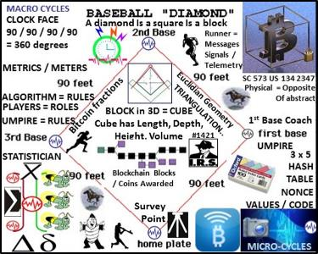 

BITCOIN PROGRAMMABLE MONEY: a.k.a. the “Internet of Money” “Bitcoin is a language” “Bitcoin’s language is time itself” Diginomics.com

BITCOIN BLOCKCHAIN DISTRIBUTED LEDGER: provides a tamper-proof data structure, providing a shared public ledger open to all. The mathematics involved are impressive, and the use of specialized hardware to construct this vast chain of cryptographic data renders it practically impossible to replicate. All transactions are embedded in the bitcoin blockchain. Use of SHA-256 cryptography ensures the integrity of the blockchain applications – all transactions must be signed using a private key or seed, which prevents third parties from tampering with it. Transactions are confirmed by the network within 10 minutes or so and this process is handled by bitcoin miners. Mining is used to confirm transactions through a shared consensus system, and usually requires several independent confirmations for the transaction to go through. This process guarantees random distribution and makes tampering very difficult.

BITNATION GOVERNANCE 2.0 [LINK](https://bitnation.co/main/) https://bitnation.co/

BITNATION provides the same services traditional governments provides, from dispute resolution and insurance to security and much more – but in a geographically unbound, decentralized, and voluntary way. BITNATION is powered by Bitcoin 2.0 blockchain technology – a cryptographically secured public ledger distributed amongst all of its users. As we like to say – BITNATION: Blockchains, Not Borders.

BUCKMINSTER FULLER’s SPACE-SHIP EARTH: Operating Manual for Spaceship Earth relates Earth to a spaceship flying through space. The spaceship has a finite amount of resources and cannot be resupplied. Buckminster Fuller Institute [LINK](http://bfi.org) BFI dot Org https://en.wikipedia.org/wiki/Operating_Manual_for_Spaceship_Earth

CASPER PoC3 Blockchain BACKBONE: Casper is a security-deposit based economic consensus protocol. Nodes, as “bonded validators”, have to place a security deposit (action called “bonding”) in order to serve the consensus by producing blocks. The protocol’s direct control of these security deposits is the primary way in which Casper affects the incentives of validators. Specifically, if a validator produces anything that Casper considers “invalid”, their deposit is forfeited along with the privilege of participating in the consensus process. The use of security deposits addresses the “nothing at stake” problem; that behaving badly is not expensive. When something is at stake, bonded validators who misbehave in an objectively verifiable manner will lose it.

CEILIOMETER, GNOCCHI, PANDA: builds metering around a data structure called samples. A sample is generated each time Ceilometer measures something. It is composed of a few fields, such as the resource id that is metered, the user and project id owning that resources, the meter name, the measured value, a timestamp and a few free-form metadata. Each time Ceilometer measures something, one of its components (an agent, a pollster…) constructs and emits a sample headed for the storage component called the collector. The collector is responsible for storing samples into a database. The Ceilometer collector uses a pluggable storage system usable with any database system

The REST API exposed by Ceilometer allows executing various reading requests on the data store. It returns the list of resources that have been measured for a particular project, or computes statistics on metrics. https://dzone.com/articles/openstack-ceilometer-and

CHAMBER OF DIGITAL COMMERCE is the world’s leading trade association representing the digital asset and blockchain industry. Our mission is to promote the acceptance and use of digital assets and blockchain-based technologies. Through education, advocacy, and working closely with policymakers, regulatory agencies and industry, our goal is to develop a pro-growth legal environment that fosters innovation, jobs and investment. [LINK](http://digitalchamber.org) http://www.digitalchamber.org

CODE FOR AMERICA Code for America partners with city, county, and state governments to redesign public services in three key areas that have high impact for communities. Together, we turn challenges into opportunities to not only serve communities better, but transform how governments think about technology. [LINK](https://codeforamerica.org)

COUNT MINIMUM SKETCH ALGORITHM: streaming algorithm Find a randomized streaming algorithm whose output (as a random variable) has the desired expectation but usually high variance (i.e., noise). To reduce the variance/noise, run many independent copies in parallel and combine their outputs. Count sketch is a probabilistic data structure designed to answer the following question: Reading a stream of elements a1, a2, a3, ..., where many elements are replicas in a given time it will provide an answer to question: how many original elements have been seen Count minimum sketch is a probabilistic data structures sacrificing certainty for space. Count minimum sketch selects 2 parameters: accuracy of the results ε and probability of bad estimate δ.

CYBER RANDOM NUMBER BEACON NIST: uses two independent commercially available sources of randomness, each with an independent hardware entropy source and SP 800-90-approved components. The Beacon is designed to provide unpredictability, autonomy, and consistency. Unpredictability means that users cannot algorithmically predict bits before they are made available by the source. Autonomy means that the source is resistant to attempts by outside parties to alter the distribution of the random bits. Consistency means that a set of users can access the source all receiving the same random string. The Beacon broadcasts full-entropy bit-strings in blocks of 512 bits every 60 seconds. Each value is time-stamped and signed, and includes the hash of the previous value to chain the sequence of values together. This prevents all, even the source, from retroactively changing an output packet without being detected. The beacon keeps all output packets and makes them available online. http://nist.gov/itl/csd/ct/nist_beacon.cfm

DASH: Unlike Bitcoin nodes, Masternodes receive payments for their service to the network – similar to demurrage charges in the Trade Reference Currency TERRA TRC. Dash includes decentralized funding, decentralized governance, decentralized storage. Dash's governance system, visit <https://dash.org.> Dash features:

- InstantX: Masternodes are able to instantly lock transactions to solve the problem of lag time in transactions,

- Self-Budgeting: To solve the problem of lack of funding for development, Masternodes can direct funds right from the blockchain to support development.

- Self-Governance: To solve the problem of making governance decisions on the future of the currency, Masternodes can vote on what development occurs.

DASH Evolution is a next-generation platform for purely decentralized e-commerce.

ECONOMIST MILTON FRIEDMAN’S K% RULE: Economist Milton Friedman predicted the rise of a computer capable of automatically adjusting the inflation rate of money. is the monetarist proposal that the money supply should be increased by the central bank by a constant percentage rate every year, irrespective of business cycles.

EQUILIBRIUM ALGORITHM / polynomial-time algorithm by John Nash Princeton University: see: http://web.cs.ucla.edu/~awm/cs288/class3.pdf

Ericsson Patents Open Money for Society 20130166398 “System And Method For Implementing A Context Based Payment System.” <https://letstalkbitcoin.com/ericsson-patents-open-money-for-society> "It is our vision that one day everyone with access to a mobile phone will be able to spend, send and receive money as easily as sending a text via SMS." "When money is open, the way we send, spend and receive money will change forever." Ericsson posted on their m-commerce site "Bitcoin And the Value of Money" which discusses "From Bartering, to Gold, to Bitcoins" Facilitation of Effective Trade, Limited Resources, and Value as a Mutual Agreement.

Background: "Local producers are sometimes forced to price goods relative to distant competition, and, because of lower production and wage costs in different parts of the world (or even country), substantially lower profit margins can be the result. There are times, however, when consumers might be willing to buy locally produced goods for the good of the society {Emphasis LTB}, and that attitude is more prevalent today than in the past. But what a consumer says they will do, and what actually occurs in practical, real shopping situations can be significantly different. Faced with competitive quality products, but disparate prices, the consumer often feels that he or she has no real choice, especially if budgets are more constrained because of uncertain economic conditions, and therefore are not what they used to be. Thus, personal economic pressures can hinder "good" buying decisions. Retailers too are cognizant of an increased awareness for the value of locally produced products. They market local producers and even arrange special sections with "good" products, i.e., those that minimally impact the environment both in terms of environmental friendly manufacturing methods, but also those articles that have been produced locally." "Thus, current economic conditions, and prevailing economic theories make it difficult, if not impossible, for an average consumer to make an impact on the local economy and the local environment, regardless of their attitudes. Therefore, it is desirable to provide methods, and systems for creating a context based payment system.

Patent Abstract: "Disclosed herein is a context based payment system. Electronic currency or coupons can be made dependent on context, and the context can be one of location or geography, time, date, distance, sound, or other devices. The value of the currency exists only if a pre-condition is fulfilled. For example, if the currency is location dependent, the value only exists in a defined area (currency value area). The goods or the service in the value-system are also context dependent, that is, they can only be sold or offered in a defined area (product value area). Accordingly, if the product value area and the currency value area overlap, a purchase and payment can be made."

ERLANG – ERLANG FOLSOM: Erlang based metrics system inspired by Coda Hale's metrics (https://github.com/dropwizard/metrics). The metrics API's purpose is to collect real-time metrics from Erlang applications and publish them via Erlang APIs and output plugins. folsom is not a persistent store. There are 6 types of metrics: counters, gauges, histograms (and timers), histories, meter_readers and meters. Metrics can be created, read and updated via the folsom_metrics module. [LINK](https://github.com/boundary/folsom) <https://github.com/boundary/folsom>

Histograms and Timers: Histograms are collections of statistical analysis values, such as mean, min, max, kurtosis and percentile. They can be used as timed update functions.

ETHEREUM “WORLD COMPUTER” combination of cryptographic architecture and Turing completeness, Ethereum virtual machine (EVM) refers to part of the protocol that handles internal state and computation. It is often referred to as the project's defining innovation over other blockchain-based systems. By taking the cryptographic payment structure of bitcoin and adding a Turing complete scripting language, The term "Turing complete" means a system capable of performing logical steps of computational functions. A technology in wide use today which employs Turing completeness is JavaScript, the programming language which powers the World Wide Web. Smart contract technology would describe a computer protocol which obviates the need for a contractual clause and, instead, is self-executing and self-enforcing. Ethereum is different than from bitcoin in that it is first and foremost a computing platform Vs a payment system. [LINK](http://www.coindesk.com/whats-big-idea-behind-ethereums-world-computer/) http://coindesk.com/whats-big-idea-behind-ethereums-world-computer/

FEDERATION (CLOUD COMPUTING): FEDERATION: from Latin: foedus, gen.: foederis, covenant characterized by a union of partially self-governing states or regions under a central (federal) government. In a federation, the self-governing status of the component states, as well as the division of power between them and the central government, are typically constitutionally entrenched and may not be altered by a unilateral decision of either party, the states or the federal political body. Individuals, organizations retain AUTONOMY to act on their own behalf. Federation: reuse of military System of Systems research, best practice guiding formation of a procedural template framework is key to forming and maintaining sustainable Trade Federations as Distributed Autonomous Organizations DAO's / DAC's Corporations. Military's organize individuals into organizations <OrgID> and Organizational Units <OU><OU><OU> dispersed autonomous groups working on collective goals synchronized in time-space

Federate is a cloud computing term. Within a federated system, an organization needs a standardized and repeatable way of describing services it makes available to teams in leagues and policies by which it runs its operations. Federated identities within groups retain their autonomy, ability to act on their own behalf. Organization Identifiers </ORG IDs> represents a business, non-profit corporation, or government entity in the American Registry of Internet Numbers ARIN database. Entities may have more than one <OrgID> for contingency planning. More than one ORG_ID enables business contingency plans for different scenarios, use cases leaders and their decisions under different circumstances. Federated Identity Management: federation describes the organization arrangements necessary for interconnection between teams, leagues, and commissions joined to achieve common goals. Federated systems need to interoperate across organizational boundaries and connect processes utilizing different technologies, identity storage, security approaches and programming models. Resources available to the group include the health or availability of individuals forming groups where monitoring is performed to ascertain if groups are mission capable or not in context with available resources and whether the group’s location is within a pre-defined geo-spatial range of a given activity or event. A federation describes the organization arrangements necessary for linkage between teams, leagues, and commissions joined to achieve common goals. Operations are performed as part of group’s activities. If trade is deemed non-equitable, groups, individuals may leave the trade federation as a network drop until conditions change or the individuals change their minds and decide to re-affiliate, re-tether to the collective.. [LINK](https://en.wikipedia.org/wiki/Federation) <https://en.wikipedia.org/wiki/Federation> See also Bitcoin Blockchain smart contract RSK [federation](http://www.coindesk.com/25-bitcoin-companies-are-trying-to-organize-into-a-smart-contract-federation/) network Buenos Aires startup [Rootstock](http://www.coindesk.com/smart-contract-1-million-bitcoin-rootstock/).

FIREFLY-HEARTBEAT ALGORITHM UNIVERSITY of BOLOGNA / HUNGARY: Firefly inspired Heartbeat Synchronization: in a paper entitled Fireﬂy-inspired Heartbeat Synchronization in Overlay Networks by the University of Bologna and Trento Italy along with the University of Szeged, Hungary: “Heartbeat synchronization strives to have nodes in a distributed system generate periodic, local “heartbeat” events approximately at the same time. Many useful distributed protocols rely on the existence of such heartbeats for driving their cycle- based execution. The heartbeat synchronization protocol for overlay networks is inspired by mathematical models of ﬂash synchronization in certain species of ﬁre ﬂies. Nodes send ﬂash messages to their neighbors when a local heartbeat triggers. Fireflies adjust the phase of their next heartbeat based on incoming ﬂash messages using an algorithm inspired by mathematical models of ﬁre-ﬂy synchronization. Heartbeat synchronization strives to have nodes in a distributed system generate periodic, local “heartbeat” events approximately at the same time. It differs from classical clock synchronization in that nodes are not interested in counting cycles and agreeing on a ID of a current cycle. There is no requirement regarding the length of a cycle with respect to real time as long as a length is bounded and all nodes agree on it eventually. The goal is to guarantee that all nodes start and end their cycles at the same time, with an error that is at least one, but preferably more, orders of magnitude smaller than a chosen cycle length.

Firefly heartbeat synchronization reduces uncertainty in stochastic networks.

Paper: Firefly-inspired Heartbeat Synchronization in Overlay Networks. Ozalp Babaoglu. Univ.

Bologna, Italy http://www.cs.unibo.it/~babaoglu/papers/pdf/SASO07-fireflies.pdf

[LINK](http://www.slideshare.net/StevenMcGee2/fireyinspired-heartbeat-synchronization): http://www.slideshare.net/StevenMcGee2/fireyinspired-heartbeat-synchronization

GAMIFICATION: application of typical elements of game playing (e.g., point scoring, competition with others, rules of play) to other areas of activity, typically as an online marketing technique to encourage engagement with a product or service

GITHUB: GitHub is a web-based Git repository hosting service. It offers distributed revision control, source code, source code management, bug tracking, feature requests, task management, and Wikis for every project. GitHub renders common formats like text, CSV, and geospatial data. GitHub includes enterprise controls to collaborate openly while limiting access to a team, to select stakeholders, or to entire organizations. [LINK](https://github.com)

GRAPHENE: form of partnership called a Decentralized Conglomerate A universal shared platform allows organizations to have a common interest in the platform itself, without the platform imposing any control on the organizations that join the universal platform ecosystem where organizations directly invest in each other.” Profits can be shared without the necessity of the companies coordinating their operations.“ By entering into a Decentralized Conglomerate means the co-ordination takes place within an automated system,” “The OpenLedger team has created the universal shared platform on which organizations can enter agreements to share their profits in exchange for community support.” Graphene Blockchain Worker System [LINK](https://bitshares.org/doxygen/group__workers.html) https://bitshares.org/doxygen/group__workers.html

HADOOP: Apache Hadoop is an open-source software framework for distributed storage and distributed processing of very large data sets on computer clusters.

Apache ZooKeeper is a software project of the Apache Software Foundation, providing an open source distributed configuration service, synchronization service, and naming registry for distributed systems. [LINK](https://en.wikipedia.org/wiki/Apache_ZooKeeper) <https://en.wikipedia.org/wiki/Apache_ZooKeeper>

Apache Storm is a free and open source distributed real-time computation system. Storm makes it easy to reliably process unbounded streams of data, doing for real-time processing what Hadoop did for batch processing. Storm has many use cases: real-time analytics, online machine learning, continuous computation, distributed RPC, ETL etc. Storm benchmark clocked it at over a million tuples processed per second per node. Trident is an abstraction on top of Storm providing higher-level constructs “cascading”, it batches groups of Tuples to 1) Make reasoning about processing easier 2) efficient data persistence with the help of an API that provides exactly-once semantics [LINK](http://www.datasalt.com/2013/04/an-storms-trident-api-overview/)

IDMAPS – SONAR HOPS: IDMaps / SonarHops internet distance estimation service: IDMaps is a global internet host distance estimation service that provides distance information used by SONAR / HOPS query / reply service. IDMaps measures, disseminates internet wide distance information to for example, Distributed Autonomous Virtual Organizations DAVOS. Higher level services for example at the macro-cycle level collect distance information to build a virtual distance map of internet by estimating distance between any IP address pair. Location is achieved by use of triangulation Distance information adjusts to “permanent” topology changes e.g., splits, joins, adds, moves, drops, merges in lieu of formal merger / acquisition. IDMaps assists Network Time Protocol (NTP) servers establish long term peering relationships. Distance Metrics focus is on latency (e.g., round-trip delay) and where possible, bandwidth. We improve stochastic harmonization by use of firefly inspired algorithms that strive to achieve synchronization by matching firefly synchronization behavior with the closest matching heartbeat snapshot cycle interval. IDMaps / SonarHops [LINK](http://www.scribd.com/doc/212582547/ton01-IDMaps-Global-Internet-Host-Distance-Estimation-Service-HOPS-Host-Proximity-Service-%E2%80%9CIDMaps%E2%80%9D-Service-SONAR-HOPS)

KRYPTON: Ethereum based smart contract platform [LINK](http://krypton.rocks) http://krypton.rocks

KONG API MANAGEMENT: Application Program Interface scalable, open source API Layer (API Gateway, or API Middleware). Kong runs in front of any RESTful API and is extended through Plugins, which provide extra functionalities and services beyond the core platform. Kong was originally built at Mashape to secure, manage and extend over 15,000 APIs & Microservices for its API Marketplace [LINK](https://getkong.org/about/) https://getkong.org/about/

LAW OF TIME Book of the Cube Time Cube Matrix Cosmic Calendar [LINK](http://bit.ly/2b7lFCZ) Law of Time dot org

LIBRARY of ALEXANDRA (The Distributed Blockchain Library) [LINK](http://www.alexandria.io/#creators-wanted)

LITTLE LEAGUE BASEBALL TOURNAMENT / GAME OF BASEBALL RULES

See Baseball Rules: http://mlb.mlb.com/mlb/official_info/official_rules/official_rules.jsp

**MEDICI Stock Exchange Blockchain Code-named “Medici,” Goal: democratize Wall Street similar to the way Bitcoin seeks to democratize currency and payments.** [**LINK**](http://www.wired.com/2014/10/overstock-com-assembles-coders-build-bitcoin-like-stock-market/)

[**http://wired.com/2014/10/overstock-com-assembles-coders-build-bitcoin-like-stock-market/**](http://wired.com/2014/10/overstock-com-assembles-coders-build-bitcoin-like-stock-market/)

**MICROSOFT Azure Blockchain as a Service (BaaS): Project Bletchley is a vision for Microsoft to deliver Blockchain as a Service (BaaS) that is open and flexible for all platforms, partners and customers.** [**https://azure.microsoft.com/en-us/blog/bletchley-blockchain/**](https://azure.microsoft.com/en-us/blog/bletchley-blockchain/) **Project Bletchley common themes:**

- Platform openness requirement.

- Identity, key management, privacy, security, operations management and interoperability

- Consortium / Federation blockchains, members-only, permissioned networks for contracts,

- Fabric for blockchain, serving as cloud platform for distributed applications

MONEYBALL: The Art of Winning in an Unfair Game Book

See: <https://datascience.berkeley.edu/moneyball-book-review/>

Moneyball: The Art of Winning an Unfair Game is a book by Michael Lewis is about the Oakland Athletics baseball team and its general manager Billy Beane. http://en.wikipedia.org/wiki/Moneyball

[](http://en.wikipedia.org/wiki/Moneyball) Firefly-Heartbeat Algorithm helps form statistical means

MONEYBALL ECONOMICS: Sabermetrics, or Moneyball, is the practice of crunching data in an effort to build a stronger and smarter team without needing to go after the rock stars of the sport who may cost a team millions. This method holds that the skill of individual players isn’t what makes or breaks a team; in the long run, the goal is to make sure that each necessary skill is accounted for, whether by one player or four. The team will work like a clock, with each cog serving its own purpose (no matter how hopeless they may be at another area).. crafting a team while staying within a meager budget.

NAMED DATA NETWORKING NDN NEXT GENERATION INTERNET: Named-data networking focus is on content caching to reduce congestion and improve delivery speed, simpler configuration of network devices, and building security into the network at the data level. Types of Packets: Communication in NDN is driven by receivers i.e., data consumers, through the exchange of two types of packets: Interest and Data. Both types of packets carry a name that identiﬁes a piece of data transmitted in one Data packet.

Overview of the Packet Contents for NDN Packet:

INTEREST: A consumer puts name of a desired piece of data into an Interest packet and sends it to network. Routers use name to forward Interest query toward data producer(s).

Data: Once Interest packet reaches a node that has the requested data, the node will return a Data packet that contains both the name and the content, together with a signature by the producer’s key which binds the two. This Data packet follows in reverse the path taken by the Interest to get back to the requesting consumer.

NET CENTRIC OPERATIONS / NET ENABLED OPERATIONS NEO

See: <https://en.wikipedia.org/wiki/Network-centric_warfare> See: <http://ncoic.org>

To determine if a organization - squad or platoon was mission capable or where it was supposed to be and equipped with the requisite resources: food, water, fuel, ammo etc. data is sampled and forwarded using a minimum of network resources e.g., time frames, intervals, epochs allocated for specific purposes. The Internet Protocol was examined closely and it was re-discovered that time interval frame assignments were left unassigned / available by internet creators (Stanford U etc.) to transport additional state meta data at some future date when a need arose. These heretofore unassigned time intervals set aside for future use would be used to carry data about the organization – the unit designation or Organizational Identifier <Org_ID>, geo-location at specified times and its resources <URN> Uniform Resource Name. Deriving common building blocks from JBFSA which also happen to be the common building blocks of Wall Street and First Response Systems (heartbeat / heartbeat messages) is a key premise. The Internet Protocol Project funding saved, the rest is history -- necessity being the mother of US Army Communication Electronic Command CECOM's "greatest" invention.

National Information Exchange Model NIEM: connects communities of people who share a common need to exchange information in order to advance their missions. [LINK](http://niem.gov)

[NXT FOUNDATION](http://blockchainwizards.com/nxtfoundation/): Nxt revolutionises the financial technology, crowdfunding and governance industries by providing not only the groundbreaking NXT crypto-currency, but also a powerful, modular toolset to build with in any way Nxt users can imagine. Nxt gives users complete freedom to create their own applications. http://blockchainwizards.com/nxtfoundation/

[OPEN LEDGER](http://bit.ly/2aVChk9): Smart #Bitcoins backed w real world collateral: decentralized exchange #blockchain. Graphene real-time blockchain technology, options:

1. Create new currency as User Issued Asset. revenue generating asset of Open Ledger using decentralized platform called OBITS. **OBITS** is a digital token blockchain [LINK](https://ccedk.com/dc/obits)

2. Create a Market Pegged Asset for coin: allow trading only in certain market pairs. Deﬁne who is allowed to hold coin by using white- and blacklists. Issuer can opt-out of his privileges indeﬁnitely for the sake of trust and reputation.

3. BitTeaser is powered by a digital token with the abbreviation “BTSR”. The network infrastructure allows users to earn tokens by blogging, selling ads, and being an active community member. [LINK](http://ccedk.com/dc/btsr) <http://ccedk.com/dc/btsr>

4. ICO Crowd Funding Economic Enterprise Engine – “Crowdfunding 3.0”:

: official form of payment used to pay for any startup services offered by CCEDK, investment with revenue streams from payments and fees, token offering real return over time, Token and investment with an exit ex: sell ICO token at level 1 ICO price until final launch. Fund buy back, burning process reducing overall supply allowing a growth in value of remaining funds over time

[**Object Management Group's (OMG) Data Distribution Service for Real-Time Systems (DDS)**](http://www.prismtech.com/vortex/technologies/data-distribution-service) is an open middleware standard that enables scalable, real-time, dependable, high performance and interoperable data exchanges between publishers and subscribers. DDS is brokerless and provides abstraction of a virtual Global Data Space, a ubiquitous, universal and fully distributed data cache.  DDS provides a standard API as a interoperable wire protocol.

OPCODE: TURING COMPLETE SCRIPTING LANGUAGE: In computing, an opcode (abbreviated from operation code) is the portion of a machine language instruction that specifies the operation to be performed. Beside the opcode itself, instructions usually specify the data they will process, in form of operands. https://**en.wikipedia.org**/wiki/**Opcode**

OPERAND PROGRAMMABLE MONEY: Operand - “In mathematics, an operand is the object of a mathematical operation, a quantity on which an operation is performed.”

“In computing, an operand is the part of a computer instruction that specifies what data is to be manipulated or operated on, while at the same time representing the data itself.”

In Operand, the transactional unit carries the execution methods and parameters that apply to the units of currency involved for that transaction. Operand is programmable money that brings the utility of everyday banking features to the unbanked and underbanked and empowers their adoption through the automata of the Operand protocol.

Operand is a currency that functions as a seamless and embedded economic layer on the web that serves as the technological underlay for payments, decentralised exchange, digital asset invocation and transfer, and smart contract issuance and execution. By embedding the instruction set of the transaction into the transaction metadata, the blockchain itself serves as the interpreter for programmed transactions. Operand creates utilities such as direct debit payments or even standing orders. Operand is trustless and non-retractable whilst being fully accountable and transparent on the public ledger. The programmable aspect enables further security on every transaction as the clients must reach network consensus on the method of execution. Smart contracts can then be forged on all aspects of exchange. [LINK](http://operand.money) Page: http://operand.money

REACT JS Java script: facilitates building of stateful & reusable UI components uses a concept called the Virtual DOM Document Object Model that selectively renders subtrees of nodes based upon state changes [LINK](https://scotch.io/tutorials/learning-react-getting-started-and-concepts)

ROSETTA STONE SYNTAX LIBRARY LEXICON CODE GUIDE REGISTRY

The Rosetta Stone is a rock stele, found in 1799, inscribed with a decree issued at Memphis, Egypt, in 196 BC on behalf of King Ptolemy V. The decree appears in three scripts: the upper text is Ancient Egyptian hieroglyphs, the middle portion is Demotic script, and the lowest is Ancient Greek. Because it presents essentially the same text in all three scripts (with some minor differences among them), the stone provided the key to the modern understanding of Egyptian hieroglyphs. It was the first Ancient Egyptian bilingual text recovered in modern times, and it aroused widespread public interest with its potential to decipher this previously untranslated hieroglyphic language. Lithographic copies and plaster casts began circulating among European museums and scholars.

Rosetta Stone concept in context with this project: a common syntax library and ability to convert <tags> to YAML indents to binary XML to various other Message Text Formats MTF to enable universal signaling / telemetry among a system of systems is needed. Structured messaging will help accelerate the process of organizing syntax into categories and forming syntax from disparate systems into template libraries simply because numbers are universal – text and symbols less so. Structured military messaging involves identifying use cases as messages and message sets commonly used to accomplish tasks that are identified by number. Data elements or Field Form Identifiers Reference Numbers or FFIRNS and Field Unit Designators as three and four digit codes unambiguously identify the purpose of the data element in numerical forms. The three and four digit codes in turn refer to text descriptions and link to symbols in symbol libraries / databases. Messages are processed / parsed in / out of common databases.

One of the DHS's top three goals is "A national common operating picture for critical infrastructure". A congressional directive states "nothing less than network centric homeland security akin to network centric warfare". This Interoperability challenge exists to this day to develop a common syntax library / Rosetta Stone among disparate systems to form an integrated, synchronized, situational awareness system of systems. Syntax / symbol source libraries that need a common reference format include:

- Named-Data Networking NDN <Content> Centric Networking (XML tags)

- OASIS TOSCA YAML document indent data encoding scheme

- GITHUB code, syntax library, Java Script OS (“tag”} convention..

The United States Message Text Format USMTF / XML MTF FORMATTED MESSAGE CATALOG includes, and describes in detail 300 + messages info exchange requirements using common, Message Text Formats MTFs. MTFs specify <CONTENT> / information agreed by group consensus presenting information in a logical, well specified and unambiguous layout resulting in a highly efficient information payload to overhead ratio. Thinking of the world’s language, symbol and syntax differences along with coder’s proclivity to design a different data </tag> {“tag”} convention with each new programming language, the use of NUMBERS as a universal method to unambiguously, consistently describe data transaction parameters is logical. See

FIGURE 5: Code Syntax Lexicon, Message Template Library http://sawconcepts.com/index/id44.html LINK

FIGURE 6: Structured Military Messaging / Data Rosetta Stone [LINK](http://sawconcepts.com/index/id52.html)

Structured military messaging identifies messages, message sets, data element fields BY NUMBER to improve the interoperability of Joint military systems. See MIL-STD-6040.

XML-MTF mapping specification and associated XML-MTF schema derivation procedures provided by NATO describe a common method of translating MTF messages to, and from, the equivalent XML representation. XML-MTF mapping specification and schema derivation procedure illustrate specific considerations such as Tag naming conventions and ambiguity issues. The XML-MTF involves detailed descriptions of MTF structure and rules, specification of legal field content, e.g. data elements

<https://en.wikipedia.org/wiki/USMTF> [LINK](https://en.wikipedia.org/wiki/USMTF) See also Binary XML

TIME SERIES DATABASE: is a software system that is optimized for handling time series data, arrays of numbers indexed by time (a datetime or a datetime range). In some fields these time series are called profiles, curves, or traces. A time series of stock prices might be called a price curve. A time series of energy consumption might be called a load profile. <https://en.wikipedia.org/wiki/Time_series_database> [LINK](https://en.wikipedia.org/wiki/Time_series_database)

TRADE REFERENCE CURRENCY TERRA TRC: Terra (The Trade Reference Currency, TRC) is the name of a possible "world currency". The concept was proposed by Belgian economist and expert on monetary systems Bernard A. Lietaer in 2001, based on a similar proposal from the 1930s.The currency is meant to be based on a basket of the 9-12 most important commodities (according to their importance in worldwide trade). Lietaer opines this would provide a currency that wouldn't suffer from inflation:

Terra = reference unit defined as standardized basket of key internationally traded commodities & services. Example: 100 Terra = 1 barrel of oil / + 10 bushels of wheat / + 20 kg of copper+ 1/10 of ounce of gold. NB: any standardizable good or service can be included. Similar stability to gold standard, but with basket instead of single commodity (more stable than any one component). Terra is Inflation-resistant by definition. The basic principle emerged from early concepts presented in an article in the French newspaper "Le Fédériste" on 1 January 1933. The idea to establish a "L'Europa – monnaie de la paix", in English "Europe - Money of peace", was given birth. The idea was enthusiastically picked up by Lietaer during an educational journey.

[LINK](https://en.wikipedia.org/wiki/Terra_(currency)): https://en.wikipedia.org/wiki/Terra_(currency)

SPATIAL ECONOMETRICS: See Dictionary of Economics [LINK](http://dictionaryofeconomics.com/article?id=pde2008_S000195)

<http://dictionaryofeconomics.com/article?id=pde2008_S000195> See also:

- central place theory

- international trade theory

- location theory

- GIS data in economics, urban economics

- monocentric versus polycentric models in urban economics

- new economic geography

- systems of cities

- urban agglomeration

- urban production externalities

- urban transportation economics

STREAMING K ALGORITHM: streaming algorithms are algorithms for processing data streams in which the input is presented as a sequence of items and can be examined in only a few passes (typically just one). These algorithms have limited memory available to them (much less than the input size) and also limited processing time per item. These constraints may mean that an algorithm produces an approximate answer based on a summary or "sketch" of the data stream in memory. [LINK](https://en.wikipedia.org/wiki/Streaming_algorithm): https://en.wikipedia.org/wiki/Streaming_algorithm

TCP/IP INTERNET “HEARTBEAT” is a metaphor, meme for epochs, time cycles, intervals generated or formed by silicon microchips used to process syntax instructions

UNIVERSAL TIME ZONE UTZ PROJECT: Universal Time Zone (UTZ) Proposed Clock At the United Nations on May 20, 2003, President, George W. Bush, announced a proposal to unify all the world's time zones into a single Universal Time Zone (UTZ). In remarks attempting to better position the USA in world affairs, Bush said, "It is unfair to the United States that other countries have the advantage of being in tomorrow while the US is stuck in today. If it is 9 PM in Washington D.C., it is already tomorrow in London or Paris. That patently unfair." [LINK](http://www.csgnetwork.com/utzproptimecalc.html) http://www.csgnetwork.com/utzproptimecalc.html

APPENDIX B: REFERENCES – ACRONYMS, METAPHORS, MEMES

Supreme Court precedent case Alice Corp Vs CLS Bank requires all internet, internet of money (Bitcoin, Blockchain) related patent applications to apply physical memes. For example, the internet TCP/IP “ping” terms is an abstraction. The internet’s “hop”, “hop count” is an abstraction. SAW Concept LLC’s application complies with the Supreme Court internet, internet of money precedent by using a Little League Baseball tournament as a main embodiment with internet technical theme derivative use cases

WATER DROP IN POND MEME

“Water drop in pond meme directs to a detailed treatises describing geo-spatial temporal intensity metrics and meters using sonar in water as opposed to a TCP/IP internet ping. Reasons for this distinction is that sonar wave behavior in water used by naval military units is well known while a TCP/IP internet “ping” is an abstract metaphor formed by time intervals / cycles / epochs / CPU clock intervals that are used to process / not process instructions describing distances between internet nodes. See figure 8 See: <http://sawconcepts.com/index/id23.html>

Water Drop in Pond area, circular, circumference metaphor – meme: areas defined by radius / circumference (124) are described in terms of radii within a circumference of a circle used to encompass or encircle a cluster of players, teams, or leagues into a discrete set. Resource items are typed, classified by <tags> measured from a known reference point i.e. ten-digit map grid coordinate describing a limited or bounded geo-spatial area described by concentric rings /circles shown to expand or contract with threshold metric changes denoting intensity i.e., an earthquake occurs during game with pre / aftershocks. Wave crests and troughs are converted into analog integer equivalents where amplitude and frequency changes convey event intensity, duration as thresholds. Discrete wave crest to trough phase changes are summed. Wave crests and troughs define cycles in terms of on, off, duration and describe slowing and speeding up of events, activities occurring within the circular geo-spatial area containing items of interest --see geo-spatial area entries, in related art for detailed treatises

Radius searches performed within circumference (124) use <tags> as search key tag / word

targets. Search results are filtered and processed by tag classes and types then saved as search

results time tagged with the micro-cycle heartbeat timestamp (112) running concurrently within

and assisting with the formation of a self-organizing reporting cycle in a macro-cycle as part of a Heart Beacon Cycle (137). Radius searches are conducted to discover threshold, duration and intensity conditions changes useful in precedence processing parameters i.e., flash override, flash, immediate, priority routine shown on appliqué acetate overlay display boards (134).

PAUL REVERE LINEAR-SEQUENTIAL MEME

The Paul Revere linear-sequential meme – metaphor is a physical meme documented in history used instead of an abstract metaphor that the internet uses called TCP/IP “hop counts”.

Hop Counts: (123): Hops are linear and sequential referring to applicant's Paul Revere

meme (126). Hops are described / defined from null as a condition / state: stationary, inactive. Hops are changes in location from point a to point b to point n. Hops follow a base running paradigm in the main embodiment (131) and are referential to TCP/IP in embodiment 1. Hops are counted incrementally where hops are changes in location e.g., home plate to first, second, and third base and back to home base (131). Hop metrics are incremental changes from null 0,1,2,3,4 - N (126) that may be positive or negative values. Hop counts are used to equitably meter, measure and derive performance or effectiveness metrics, meters. Time stamps (112) form time frames, temporally bound hops e.g., in time and space. Erlang logic is useful in establishing time boundaries and time limits among geo-spatially disperse events.

Time filtered and spatially metered reports are comprised of state meta-data snapshot / heartbeat message / sync delta messages where state meta data is harvested during micro-cycles then posted / displayed during longer macro-cycles

See hop count treatise referential to internet / TCP/IP treatises Figure 11 <http://sawconcepts.com/index/id17.html> <http://sawconcepts.com/index/id23.html>

IEEE 802.11AG is used for hop by hop detection and control for epoch assignment and hop

counts management and for hop by hop detection function to determine hop by hop count

corresponding to machine readable and executable null / 0 and steps from null representing hop

counts e.g., +1, +2, +3, +4 and / or -1, -2, -3, -4 Paul Revere linear, sequential metaphor

indicating distance traveled in context with router / server / switch / node traversal

IEEE 802.11 HbH hop by hop control supporting Paul Revere, rain drop in pond metaphor

metrics of increases / decreases in thresholds and by intensity, duration and hop count sums:

IEEE C37.118 Harmonization and Synchronization for heartbeat data pulses and watchdog

heartbeat functions in electrical power grid applications to base micro-grid arbitrage when used

with user, customer, client, organization selected beacon broadcast type technologies

US 7,571,430 Trimbell, et al. August 4, 2009 Adaptive dispatch table based on templates

Original Assignee: LSI Logic Corporation Inventors: Forrest Trimbell,

US 20080208595 System and method for capturing steps of a procedure Inventors: Lloyd Elder

Edmonton, CA Publication date: 2008-08-28

NATO's [#interoperability](https://twitter.com/hashtag/interoperability?src=hash) system of systems framework i.e., sync delta's, structured data exchange alpha numeric brevity codes, symbol sets... is the best starting point - in my opinion. [#Coindesk](https://twitter.com/hashtag/Coindesk?src=hash): The Opportunity for Interoperable Chains of Chains [LINK](http://www.sawconcepts.com/index/id52.html)

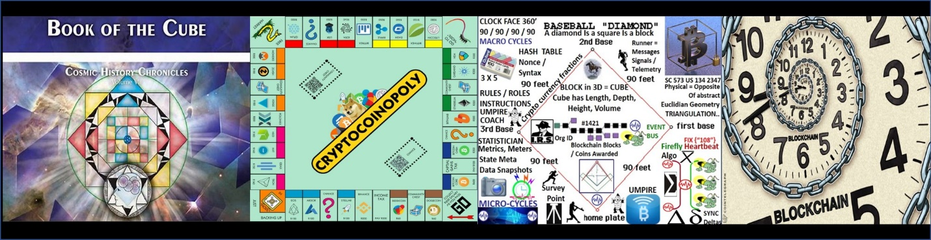

The Heart Beacon Cycle Time – Space Meter USPTO 13/573,002 <http://sawconcepts.com/index>

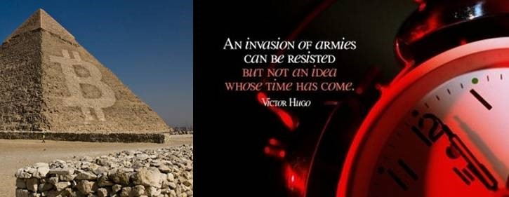

 **.** 

The **Heart Beacon Sculpture, Portland Oregon USA**: [LINK](https://www.codaworx.com/project/heart-beacon-city-of-portland) <https://codaworx.com/project/heart-beacon-city-of-portland>

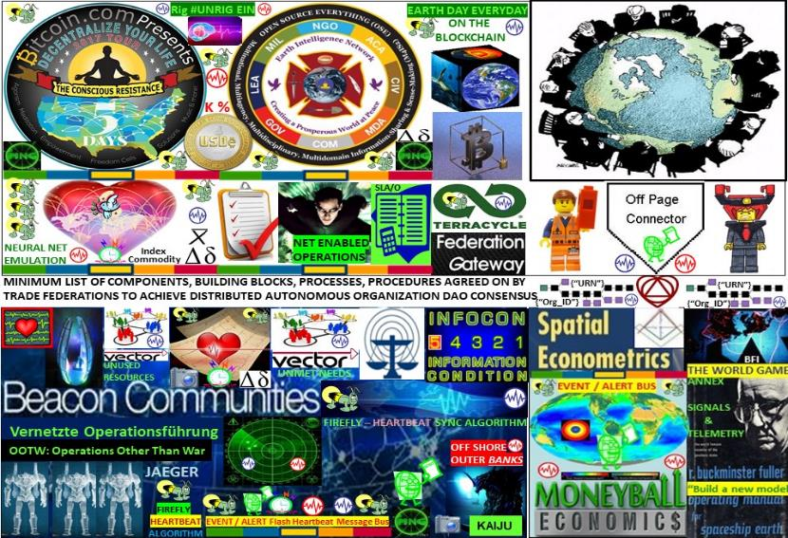

**FIGURE 1: The Heart Beacon Cycle Time – Space Meter: It’s TIME**



**FIGURE 2: Adaptive Procedural Template Checklist: The Heart Beacon Cycle Time Space Meter** [LINK](http://www.sawconcepts.com/index/id3.html)



**Figure 3: Swords to Plowshares Batllefield Digitization Net Enabled Operations NEO / HBC** [LINK](https://sawconcepts.com/index/id79.html)



**FIGURE 4: Everyday can be Earth Day on the Bitcoin Blockchain** [**LINK**](http://sawconcepts.com/index/id56.html)<http://sawconcepts.com/index/id56.htm>



**FIGURE 5: All Internet artifacts are formed using 1) time cycles – epochs 2) syntax:** [**LINK**](http://sawconcepts.com/index/id4.html)[**http://sawconcepts.com/index/id4.html**](http://sawconcepts.com/index/id4.html)



**FIGURE 6: Alice Corp Vs CLS Bank / Heart Beacon Cycle** [**LINK**](http://sawconcepts.com/index/id58.html) **http://sawconcepts.com/index/id58.html**



**FIG 7: PATENT FUSION: SYNERGY AMONG PATENTS, PATENT APPLICATIONS** [**LINK**](http://sawconcepts.com/index/id61.html) **http://sawconcepts.com/index/id61.html**

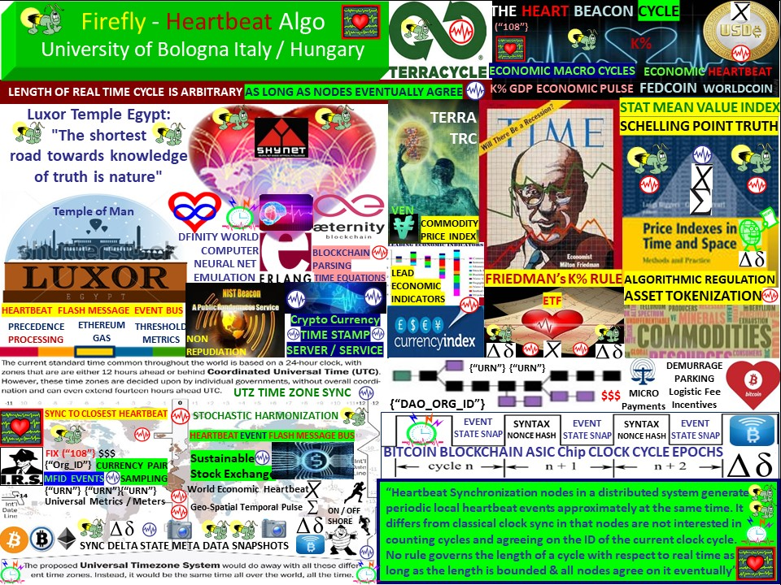

**Figure 8: Firefly Inspired Heartbeat Synchronization Algorithm** [**http://sawconcepts.com/index/id22.html**](http://sawconcepts.com/index/id22.html)[**LINK**](http://sawconcepts.com/index/id22.html)



**FIGURE 9: ECONOMIST MILTON FRIEDMAN’S K% RULE** [**http://sawconcepts.com/index/id43.html**](http://sawconcepts.com/index/id43.html)[**LINK**](http://sawconcepts.com/index/id43.html)



**FIGURE 10: TERRA TRC TRADE REFERENCE CURRENCY COMMODITY BASED / BITCOIN BLOCKCHAIN** [**LINK**](http://sawconcepts.com/index/id39.html)



**FIGURE 11: Code Syntax Lexicon, Message Template Library** [**http://sawconcepts.com/index/id44.html**](http://sawconcepts.com/index/id44.html)[**LINK**](http://sawconcepts.com/index/id44.html)

**..**

**FIGURE 12: Structured Military Messaging / Data Exchange FFIRNS, FFUDNS**



**FIGURE 13: Situation Awareness Reference Architecture SARA / Heart Beacon Cycle** [**LINK**](http://sawconcepts.com/index/id26.html)



**FIGURE 14: MAIN USE CASE: FEDERATE** [**LINK**](http://sawconcepts.com/index/id5.html) **http://sawconcepts.com/index/id5.html**



**FIGURE 15: “KEYSTONE” FEDERATION** [**LINK**](http://sawconcepts.com/index/id6.html) **http://sawconcepts.com/index/id6.html**



**Figure 16: NIST CYBER BEACON / HEART BEACON CYCLE** [**LINK**](http://sawconcepts.com/index/id25.html)[**http://sawconcepts.com/index/id25.html**](http://sawconcepts.com/index/id25.html)



**FIGURE 17: FIXING BITCOIN’S SIX ISSUES**



**FIG 18: Bitcoin Blockchain Proof of Stake Universal Coder’s Guide** [**http://sawconcepts.com/index/id45.html**](http://sawconcepts.com/index/id45.html)[**LINK**](http://sawconcepts.com/index/id45.html)



**Figure 19: Bitcoin Blockchain Proof of Work Universal Meme** [**LINK**](http://sawconcepts.com/index/id50.html)[**http://sawconcepts.com/index/id50.html**](http://sawconcepts.com/index/id50.html)



**FIGURE 20: Bitcoin Classic / Core / Unlimited // USPTO 13/573,002**



**FIGURE 21: MICROSOFT BLETCHLEY BLOCKCHAIN MEDIATION SERVICE**



**Fig. 22 SAWTOOTH / POET Proof of Elapsed Time** [**LINK**](http://sawconcepts.com/index/id49.html)[**http://sawconcepts.com/index/id49.html**](http://sawconcepts.com/index/id49.html)



**FIGURE 23: Segregated Witness / Project Lightning:** [**LINK**](http://sawconcepts.com/index/id51.html)[**http://sawconcepts.com/index/id51.html**](http://sawconcepts.com/index/id51.html)



**FIGURE 24: BITCOIN NG NEXT GENERATION / HEART BEACON CYCLE:** [**LINK**](http://sawconcepts.com/index/id57.html)



**FIGURE 25: Brave New Coin B-WAP / HEART BEACON CYCLE** [**LINK**](http://sawconcepts.com/index/id53.html)



**FIGURE 26: DASH / HEART BEACON CYCLE** [**LINK**](http://sawconcepts.com/index/id54.html)[**http://sawconcepts.com/index/id54.html**](http://sawconcepts.com/index/id54.html)

** FIGURE 27: ETHEREUM – CASPER / HBC** [**LINK**](http://sawconcepts.com/index/id62.html)[http://sawconcepts.com/index/id62.html](http://sawconcepts.com/index/id62.html)

**FIGURE 28: HYPERLEDGER / HEART BEACON CYCLE** [**LINK**](http://sawconcepts.com/index/id59.html)



**FIGURE 29: R3 CORDA / HEART BEACON CYCLE** [**LINK**](http://sawconcepts.com/index/id60.html)



**FIGURE 30: DFINITY Blockchain Nervous System BNS / HBC** <http://sawconcepts.com/index/id57.html>[LINK](http://sawconcepts.com/index/id57.html)



**Fig 31 BFT-SMART / Heart Beacon Cycle Comparison** <http://sawconcepts.com/index/id69.html>



**FIGURE 32: OpenBazaar Free Trade on the Bitcoin Blockchain / HBC Synergy** [LINK](http://sawconcepts.com/index/id73.html) **http://sawconcepts.com/index/id73**



**FIGURE 33: BITCOIN LAND USE MEME / IRS MEME 1421:** [**LINK**](http://sawconcepts.com/index/id33.html)[**http://sawconcepts.com/index/id33.html**](http://sawconcepts.com/index/id33.html)



**Figure 34: Distance Estimation Service IDMaps / SonarHops** [**LINK**](http://sawconcepts.com/index/id24.html)[**http://sawconcepts.com/index/id24.html**](http://sawconcepts.com/index/id24.html)



**FIGURE 35 EPCIS RFID / Heart Beacon Cycle Time – Space Meter Applique’ Overlay**



**FIGURE 36: BIG DATA THE NEXT OIL**



**FIGURE 37: ENERGY ATTENUATES OVER DISTANCES** [**LINK**](http://sawconcepts.com/index/id16.html) **http://sawconcepts.com/index/id16.html**



**Figure 38: SPACE – TIME BEACON** [**LINK**](http://sawconcepts.com/index/id23.html)[**http://sawconcepts.com/index/id23.html**](http://sawconcepts.com/index/id23.html)



**Fig 39: Universal Time Zone UTZ Stochastic Harmonization / Sync** [**LINK**](http://sawconcepts.com/index/id48.html)[**http://sawconcepts.com/index/id48.html**](http://sawconcepts.com/index/id48.html)



**Fig 40: FedCoin – WorldCoin ECONOMIC HEARTBEAT** [LINK](http://sawconcepts.com/index/id9.html)



**FIG 41: High Frequency Flash Trade Breaker / Algorithmic Regulation** [**LINK**](http://sawconcepts.com/index/id18.html) **http://sawconcepts.com/index/id18.html**



**FIGURE 42: BITCOIN BLOCKCHAIN TRADENET** [**LINK**](http://sawconcepts.com/index/id7.html) **http://sawconcepts.com/index/id7.html**



**FIGURE 43: BLOCKCHAIN BLUEPRINT FOR A NEW ECONOMY** [**LINK**](http://sawconcepts.com/index/id11.html) **http://sawconcepts.com/index/id11.html**

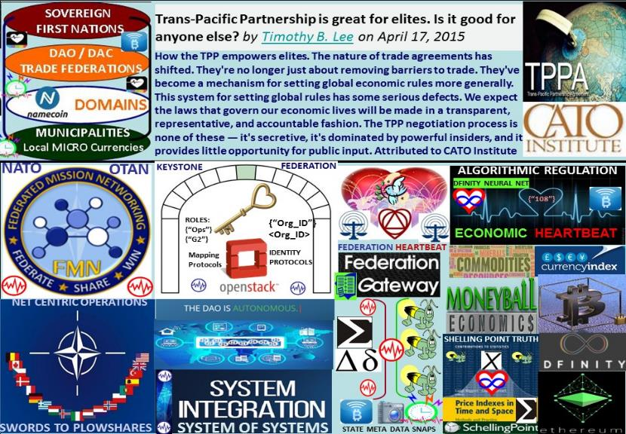

**FIGURE 44: EQUITABLE TRADE FEDERATION AGREEMENTS** [**LINK**](http://sawconcepts.com/index/id10.html) **http://sawconcepts.com/index/id10.html**



**FIGURE 45: VERITASEUM “CAPSTONE BLOCK”** [**LINK**](http://sawconcepts.com/index/id12.html) **http://sawconcepts.com/index/id12.html**



**FIGURE 46: BITCOIN BLOCKCHAIN, MESH ECONOMY** [**LINK**](http://sawconcepts.com/index/id34.html) **http://sawconcepts.com/index/id34.html**



**FIGURE 47: GAMIFICAIION / HEART BEACON CYCLE** [**http://sawconcepts.com/index/id30.html**](http://sawconcepts.com/index/id30.html)[**LINK**](http://sawconcepts.com/index/id30.html)



**FIGURE 48: SWORDS TO PLOWSHARES** [**LINK**](http://sawconcepts.com/index/id36.html)[**http://sawconcepts.com/index/id36.html**](http://sawconcepts.com/index/id36.html)



**FIGURE 49: ERICSSON ERLANG / ERICSSON’S OPEN MONEY**



**FIGURE 50: METRICS / METERS**



**FIGURE 51: Electronic Government as a Service / HBC Synergy** [LINK](https://sawconcepts.com/index/id77.html)<http://sawconcepts.com/index/id77.html>



**FIGURE 52: HashGraph comparison / synergy with HBC**



**FIGURE 53: IOTA TANGLE DAG / Heart Beacon Cycle Time – Space Meter synergy**



**FIGURE 54 RIPPLE RTP / HBC Synergy**



**FIG 55: SPACESHIP EARTH OPERATING MANUAL SIGNALS ANNEX** [**LINK**](http://sawconcepts.com/index/id42.html)[**http://sawconcepts.com/index/id42.html**](http://sawconcepts.com/index/id42.html)

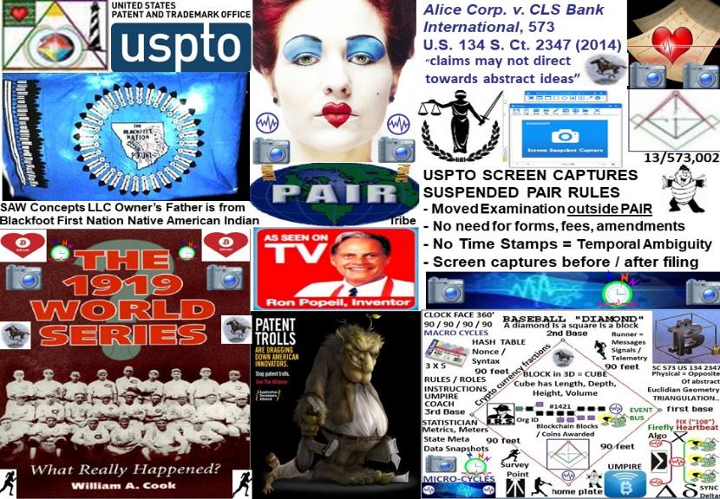

**FIGURE 56: APPLICATION 13/573,002 SNAPSHOT** [LINK](https://sawconcepts.com/index/id46.html)

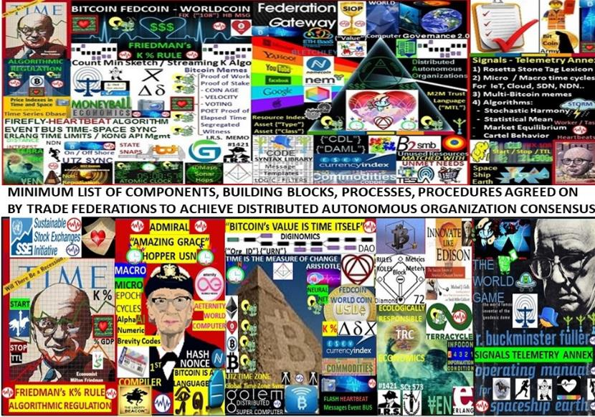

**FIGURE 57: ADAPTIVE PROCEDUREAL CHECKLIST BANNERS**



**FIGURE 58: Germany Army H.A.N.D.S System of Systems Template Framework** [LINK](http://www.sawconcepts.com/index/id20.html)



The Heart Beacon Cycle Time — Space Meter USPTO 13/573,002 is built standing on the shoulders of giants. Milton Friedman and his K% rule, Admiral “Amazing Grace” Hopper and the world’s first computer compiler and the alpha-numeric brevity codes ideal for today’s Internet of Things, Artificial Intelligence A.I. global neural network emulation algorithm

**"One resists the invasion of armies; one does not resist the invasion of ideas"**



**“A day will come when there will be no battlefields, but markets open to commerce and minds open to ideas”. Victor Hugo**

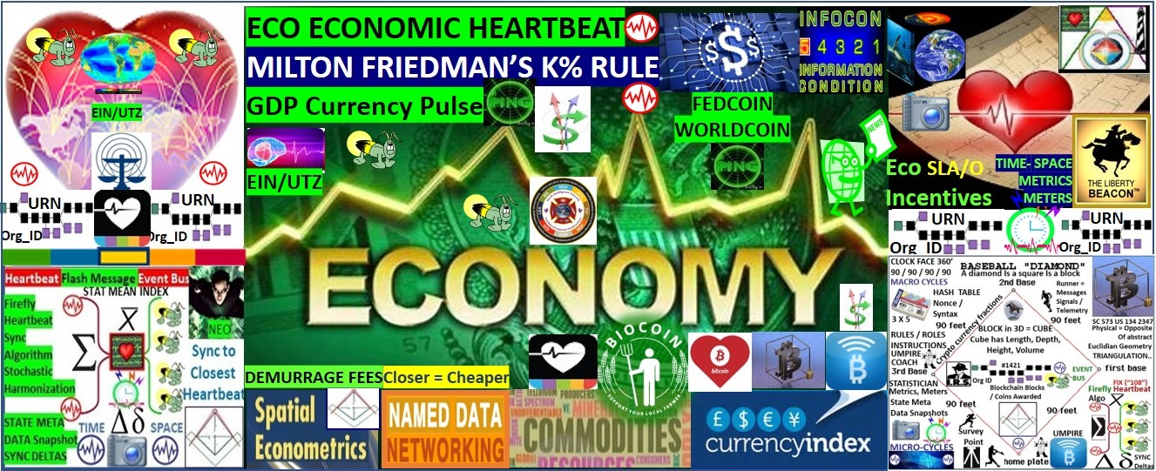

Economic RESET is a mathematical certainty. Question: Do we RESET the global system of systems as is business as usual or will we re-engineer using NATO / DARPA / DOD's system of systems engineering framework standing on the shoulders of giants to convert swords to plowshares? Medium [LINK](https://medium.com/@heart.beacon.cycle/eco-sustainable-economic-heartbeat-43e4e30246da)

[#Economic](https://twitter.com/hashtag/Economic?src=hash) [#RESET](https://twitter.com/hashtag/RESET?src=hash) is a mathematical certainty. Do we [#RESET](https://twitter.com/hashtag/RESET?src=hash) the global system of systems as is or will we re-engineer using NATO / DARPA / DOD system of systems engineering framework standing on the shoulders of giants to convert swords to plowshares? [#blockchain](https://twitter.com/hashtag/blockchain?src=hash) [#econometrics](https://twitter.com/hashtag/econometrics?src=hash)

Eco sustainable Economic Heartbeat: It’s TIME: IF Climate Change causes a drop in crop commodity food production by 20–25 % while population continues to grow, THEN it follows that this condition will become a matter of national security. It’s TIME to implement an Ecologically Sustainable Economic Heartbeat ELSE face greater > chaos by not reusing proven tactics.

Is it time to build a new [e](https://gab.ai/hash/economic)conomic system of systems framework yet? Why wait for DEFCON Level 2 to start a system of systems sustainable project?

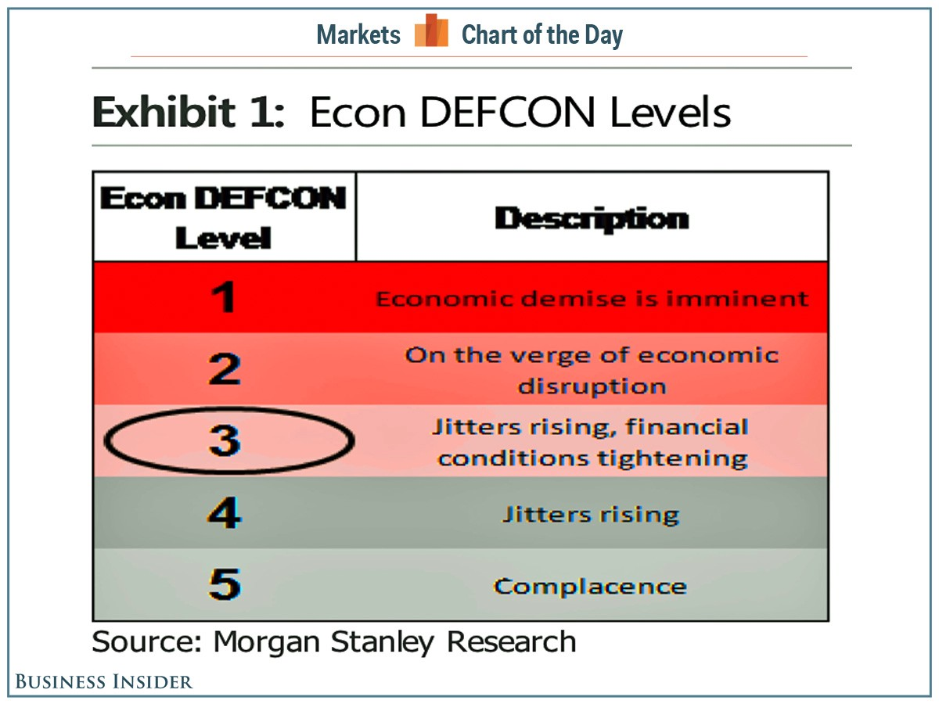

IF climate change causes a drop in crop commodity by 20–25 % while population grows, THEN this condition will become a matter of national security. THEN this will require revisiting Belgian Economist Bernard Lietaer’s TRC Trade Reference Currency ELSE face > chaos

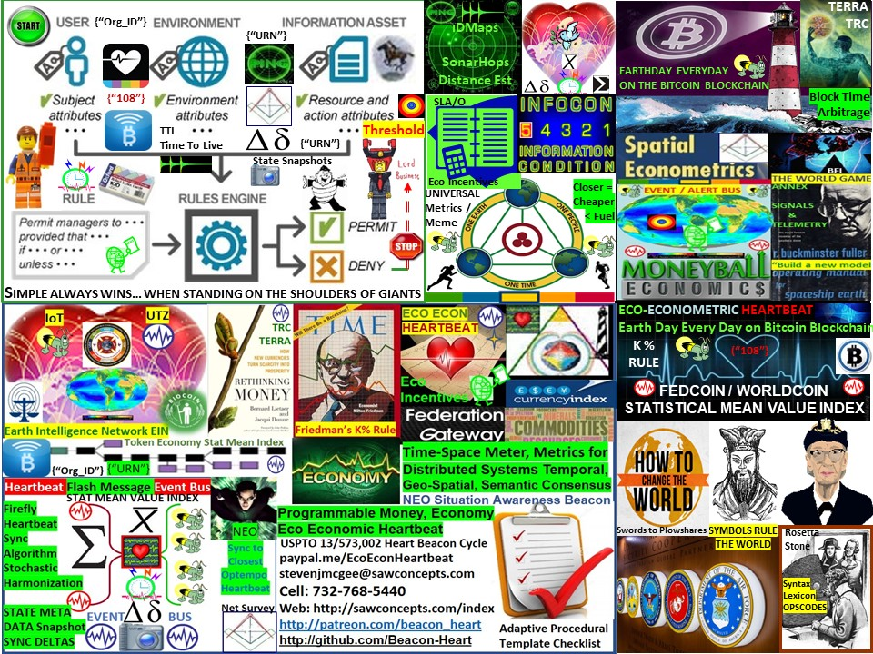

Digital Nations need an (Eco sustainable) Economic Heartbeat 😍 Ecologically sustainable Economic Heartbeat = system of systems engineering signaling, telemetry support framework for the DAAE Distributed Autonomous Automated Economy

The Heart Beacon Cycle Time - Space meter is a distributed system of systems engineering signaling -telemetry temporal, geo-spatial, semantic - syntactic sync & consensus foundation framework supporting the DAAE Distributed Autonomous Automated Economy Eco - Economic Heartbeat. It is time to establish an ecologically sustainable economic heartbeat… PROJECT BEACON: Reuse NATO's system of systems syntax lexicon OPSCODE brevity code structured data exchange, heartbeat micro to macro cycle Universal Time Zone UTZ sync to support the EIN Earth Intelligence Network neural net emulation & improve temporal, geo-spatial, and syntactic - semantic consistency, interoperability among myriad programmable money memes.

The Heart Beacon Cycle is an adaptive procedural template checklist of things, processes, tools, building blocks useful to form, maintain Eco-responsible trade federations. Each item in the procedural template checklist links to a detailed treatise. We can synchronize ourselves, our cities, towns, cyber-communities in time — space for a common purpose: shared, common, ecologically sound, responsible econometrics. See the Law of Time organization’s site and the 441 Time Cube described by the late Dr. Jose Arguelles LAW OF TIME [site](http://lawoftime.org) [http://lawoftime.org](http://lawoftime.org/)

The Heart Beacon Cycle Time - Space meter is a swords to plowshares DAO Distributed Autonomous Organization project using NATO’s Situational Awareness system of systems engineering framework, processes, procedures and internet building blocks to establish an Ecologically sustainable Economic Heartbeat, neural network emulation for the EIN Earth Intelligence Network and heartbeat sync pulse for a Universal Time Zone UTZ supporting a one world currency. It’s syntax lexicon library of OPSCODE brevity codes used in programmable money, the programmable economy is descriptive of all things internet, internet of money down to the quantum computing, quantum blockchain level. a.k.a Project BEACON / Medium Article LINK <https://bit.ly/2s6Fnav>

Crypto economics needs a universal syntax lexicon digital base Artificial Intelligence A.I., quantum blockchain heartbeat beacon to synchronize, sample tokenized commodities across a stochastically harmonized UTZ Universal Time Zone supporting an Earth Intelligence Network EIN see Robert David Steele’s #UNRIG proposal @ [http://robertdavidsteele.com](http://robertdavidsteele.com/)

Economic #RESET is a mathematical certainty. Do we RESET the global system of systems as is or will we re-engineer using NATO system of systems engineering framework standing on the shoulders of giants to convert swords to plowshares?

Eco Economic Heartbeat: It’s TIME: IF Climate Change causes a drop in crop commodity food production by 20–25 % while population continues to grow, THEN it follows that this condition will become a matter of national security. It’s TIME to implement an Ecologically Sustainable Economic Heartbeat ELSE face > greater chaos by not leveraging proven system of system structured data exchange tactics.

IF climate change causes a drop in crop commodity by 20–25 % while population grows, THEN this condition will become a matter of national security. THEN this will require revisiting Belgian Economist Bernard Lietaer’s TRC Trade Reference Currency ELSE face > chaos LINK <http://lietaer.com/2010/01/terra/> If, when climate change reduces crop commodity production while population continues to rise, it follows that this could become a National Security issue — then, an ecologically sustainable economic heartbeat would be obviously needed. Why wait until crisis, DEFCON 2 stage?

Ecologically sustainable economic transactions need to be incentivized among the world’s Ecological and Economic system of systems. The world’s systems need to be time-space synchronized, stochastically harmonized across the UTZ Universal Time Zone via heartbeat messages composed with OPSCODE brevity codes drawn from a universal structured data exchange syntax lexicon with over 300 use case templates.

System of Systems Framework: Crypto economics needs a universal syntax lexicon digital base Artificial Intelligence A.I., quantum blockchain heartbeat beacon to synchronize, sample tokenized commodities across a stochastically harmonized UTZ Universal Time Zone supporting an Earth Intelligence Network EIN. Is it time to build a new economic system of systems framework yet? Why wait for DEFCON Level 2 to start a system of systems sustainable project? All things #internet, net of #money #blockchain #cryptocurrencies rely on unicast, multicast — like DoD / NATO’s #DAO Distributed Autonomous Organization system of systems — a term coined by the RAND Corporation circa 2000. Programmable money’s improvements are in cryptography

Nobel Prize winning Economist Milton Friedman’s K% rule is what I call an “economic heartbeat” K-Percent Rule. DEFINITION of ‘K-Percent Rule’. The K-Percent Rule was a proposal by economist Milton Friedman that the central bank should increase the money supply by a constant percentage every year. The K-Percent Rule proposes to set the money supply growth at a rate equal to the growth of real GDP each year. K-Percent Rule — Investopedia <http://www.investopedia.com/terms/k/k-percent-rule.asp>

SOURCE PAGE: <http://sawconcepts.com/index> "One method fits many.. not one size fits all